Finance Resume Template: A Format Built for Banking and Consulting
Meta description: WSG founder Stephen Turban shares a one-page finance resume template with a filled sample, section rules, and the tweaks that tilt it to banking or consulting.

"I made two resumes, one for banking and one for consulting, and neither one has gotten me a single first round." A junior at a large state school, call her Priya, said that on our first call last fall. Her banking version had cut her consulting club to one line because she figured bankers wouldn't care. Her consulting version had cut her boutique banking summer to two bullets with no numbers because she figured consultants wouldn't care. Each page was weaker than one good page would have been, and the finance resume template below is the page she should have had from the start.

I'm Stephen Turban, founder of WSG. I went to Harvard, went through McKinsey's on-cycle recruiting, and now read a lot of resumes from students who are recruiting for banking and consulting at the same time. Priya's fix took one evening: one page, one format, and about six small changes between the version she sent to banks and the version she sent to consulting firms. She had first rounds at both kinds of firm within a month.

This guide is that template. You get the blank version with placeholders, a filled sample for a junior who recruited for both tracks, the rules for each section, how a banking screener and a consulting screener each read the page, and the small changes that tilt the same page one way or the other.

What format should a finance resume use?
One page, reverse chronological, five sections in a fixed order: a header line, Education, Experience, Leadership & Activities, Additional Information. Black text, one plain font at 10 to 11 point, 0.5 to 0.75 inch margins, no photo, no objective, no columns, saved as a PDF. The finance resume format that works is the one every banker and consultant has already seen a thousand times, because a screener who recognizes the layout spends their seconds on your content instead of on finding it.

Can the same resume work for banking and consulting?
Yes, and it should. Both screens read the same five things first: your school and GPA, your most recent relevant experience, whether your bullets carry numbers, whether you have run something, and whether the formatting is clean. The same one-page finance resume works for both tracks with about six small changes, and you end up with two PDFs that share roughly 90 percent of their text. The sections below walk through those changes one at a time.

1. One page works for both tracks because both screens happen fast
Start with how many resumes arrive. Goldman Sachs said about 360,000 people applied for its 2025 internship class and about 2,600 got in, which works out to 0.7 percent [VERIFY: Goldman Sachs 2025 intern class figures, Fox Business citing Goldman's LinkedIn post; the 2026 class was reported at about 2,500 interns]. Nobody reads 360,000 resumes slowly. At a bank, the first pass on your resume is often done by an analyst or associate who has a live deal open in another window, and from what students tell me afterward, that first pass takes 20 to 30 seconds.

A second page doesn't get those seconds. It gets skipped.

Consulting firms read differently but arrive at the same rule. A consulting screener is looking for evidence in four specific categories and scoring what they find, so a second page spreads the same evidence over twice the space. Consultants also judge one skill above almost everything else: can you say the important thing in less room than the person next to you? A two-page resume answers that question before anyone reads a bullet. A second page tells a banker you can't prioritize and tells a consultant you can't synthesize, and both read it as a preview of your work.

There is a mechanical reason too. Almost every bank and consulting portal runs on an applicant tracking system, which is software that reads your PDF and sorts the text into fields: name, school, employer, title, dates. A plain single-column page parses into the tracking system's fields correctly, and a page with columns, icons or a photo often doesn't. Two columns, text boxes and images scramble the parse, so your "Investment Banking Summer Analyst" title can land in the wrong field or disappear. When a recruiter later searches the system for that title, a scrambled resume doesn't come up.

So the format is boring on purpose.

The skeleton below is the same one in my investment banking resume template, and the live consulting resume checklist grades a page against the same shape. This article is about the shape itself and how one page serves both readers.

2. The finance resume template: five sections in a fixed order
Everything in brackets is a placeholder. Replace it, delete the brackets, and keep the punctuation and order exactly as shown. Under each section is a short note on what belongs there. The same template is available as an editable Word file, and the filled sample in section 3 as a one-page PDF [VERIFY: add the download links for "WSG One-Page Resume Template.docx" and "Sample Finance Resume (Jane Doe).pdf" once uploaded to Wix].

[FIRST LAST]
[(555) 555-0123] | [first.last@university.edu] | [City, State] | [linkedin.com/in/first-last]

EDUCATION

[University Name], [City, State]. [Bachelor of Science or Arts in Major], [Minor in Minor], Expected [Month Year]

- GPA: [X.XX / 4.00] | [Honors, Dean's List with semesters, scholarships] | [SAT: XXXX or ACT: XX, optional, see the rules in section 4]
- Relevant Coursework: [Four to six courses, most relevant first]

EXPERIENCE

[Employer], [City, State]. [Title], [Group or Team if relevant], [Mon Year] to [Mon Year]

- [Verb] [what you built or did] for [what it was for, with a size]; [how you did it or who used it]; [the number or outcome]
- [Second bullet, same formula, a different piece of the work]
- [Third bullet, optional, only for your most relevant role]

[Employer], [City, State]. [Title], [Mon Year] to [Mon Year]

- [Bullet]
- [Bullet]

LEADERSHIP & ACTIVITIES

[Organization], [University Name], [City, State]. [Title] | Previous Roles: [Earlier titles if any], [Mon Year] to Present

- [What you lead, with the size of the group, budget or program, and what changed because you led it]
- [One thing you built or started, with a number]

[Competition, team, business or second organization], [City, State]. [Role], [Mon Year or range]

- [Result first, then what you did to get it]

ADDITIONAL INFORMATION

- Technical Skills: [Finance and data tools you have actually used, most relevant first]
- Languages & Certifications: [Language with proficiency; modeling or market certifications]
- Interests: [Three to six specific interests a stranger could ask you about for five minutes]

A few notes on what goes where.

The header line is one line. Name on top in capitals, then phone, a professional email, your city and state, and a LinkedIn URL you have cleaned up. No street address, no second phone, no "U.S. Citizen" line unless an application asks for it.

Education goes first on an undergrad resume because it is the first thing both screens read. One line for the degree, one for GPA and honors, one for coursework. The coursework line exists to show a screener that you have taken the quantitative classes, so it carries course names, not grades.

Experience is every paid or formal role, in reverse chronological order, with the entry line in one fixed pattern: employer, city, title, dates. Bullets under each role follow the formula in section 4. Two or three bullets per role, and three only for the roles that carry the page.

Leadership & Activities is where a sophomore's page gets most of its weight and where a consulting screener spends most of their time. Clubs you run, teams you captain, competitions you placed in, businesses you started. Membership alone doesn't earn a line. Running something does.

Additional Information is three lines, no more. Tools you have actually opened, languages you can actually hold a conversation in, and interests specific enough to start one.

3. The filled sample: a junior who recruited for banking and consulting at once
This is the page for a fictional junior, call her Jane Doe, at a large public university. She did a boutique banking summer, leads projects in a student pro bono consulting group, works as a research assistant in the economics department, placed in a case competition, and runs the education side of a campus finance society. Every firm and program is a placeholder, and every number is illustrative.

JANE DOE
(555) 555-0199 | jane.doe@email.com | Chicago, IL | linkedin.com/in/jane-doe-sample

EDUCATION

State University, Chicago, IL. Bachelor of Business Administration in Finance, Minor in Economics, Expected May 2028

- GPA: 3.78 / 4.00 | Dean's List, all four semesters | ACT: 34 | University Honors College
- Relevant Coursework: Corporate Finance, Financial Accounting, Valuation, Econometrics, Business Statistics, Intermediate Microeconomics

EXPERIENCE

Regional Boutique Investment Bank, Chicago, IL. Investment Banking Summer Analyst, Jun 2026 to Aug 2026

- Built the trading comparables and precedent transactions analyses for a $45MM sell-side mandate for a founder-owned logistics company; the valuation range from the analysis set the first-round bid guidance the bank sent to 9 buyers
- Drafted 14 pages of the confidential information memorandum, including the industry overview and the customer concentration section; the managing director reused the section in the management presentation to 4 second-round bidders
- Built and maintained a buyer list of 110 strategic and sponsor contacts across two live processes; tracked outreach, NDAs and first-round indications in the log the deal team reviewed on the weekly client call

Student Pro Bono Consulting Group, State University, Chicago, IL. Project Lead | Previous Role: Consultant, Sep 2025 to Present

- Built a menu-level margin analysis of 40 items for a 12-location regional coffee chain as lead of a 5-person, 10-week pricing project; recommended three price changes the owner adopted, which raised the average ticket by 6 percent over the following quarter
- Ran a 300-response customer survey and 15 store manager interviews; found that 2 of the 12 locations drove 30 percent of food waste cost and recommended an ordering change the chain rolled out to every store
- As a consultant, built the market sizing and competitor analysis for a nonprofit's after-school tutoring expansion; the board used the analysis to approve two new sites

Department of Economics, State University, Chicago, IL. Research Assistant, Labor Economics, Sep 2025 to Present

- Cleaned and merged four years of county-level employment data (about 120,000 rows) in Stata and Python for a study of minimum wage effects on restaurant hiring; built the summary tables used in the working paper's first draft
- Wrote the summary of 25 prior studies that became section 2 of the working paper; co-presented the preliminary results at the department's undergraduate research symposium

LEADERSHIP & ACTIVITIES

Undergraduate Finance and Consulting Society, State University, Chicago, IL. Vice President of Education | Previous Role: Member, Sep 2024 to Present

- Designed and run a 6-week interview prep series for 35 members each semester covering accounting, valuation and case fundamentals; members have placed at 4 investment banks and 3 consulting firms over the past two recruiting cycles
- Recruited 8 alumni speakers and raised $3,000 in corporate sponsorship to fund a two-day case competition for 60 students; grew paid membership from 90 to 140 in one year

Regional Undergraduate Case Competition, Chicago, IL. Team Captain, Mar 2026

- Led a 4-person team to second place out of 18 teams with a market entry recommendation for a grocery delivery service; built the $220MM market sizing and the unit economics model and presented the 20-slide deck to a panel of consultants and operators

Independent ACT Tutoring Business, Chicago, IL. Founder, Jun 2024 to Present

- Tutored 20 high school students over two summers with a self-built 8-week curriculum; students gained an average of 5 points, and referrals filled the second summer without advertising

ADDITIONAL INFORMATION

- Technical Skills: Excel (financial modeling), PowerPoint, S&P Capital IQ, PitchBook, Stata, Python (pandas), SQL
- Languages & Certifications: Wall Street Prep Financial Modeling; Fluent Spanish; Conversational Portuguese
- Interests: Triathlon Training, Crossword Construction, Sourdough Baking, Chicago Architecture Tours, College Basketball

That's the whole page: twelve bullets across Experience and Leadership, three lines of Additional Information, and on the real page no blank line between an entry and its bullets (the spacing you see here is the web layout, not the resume). Twelve bullets with a number in every one of them make a stronger page than twenty bullets that describe duties.

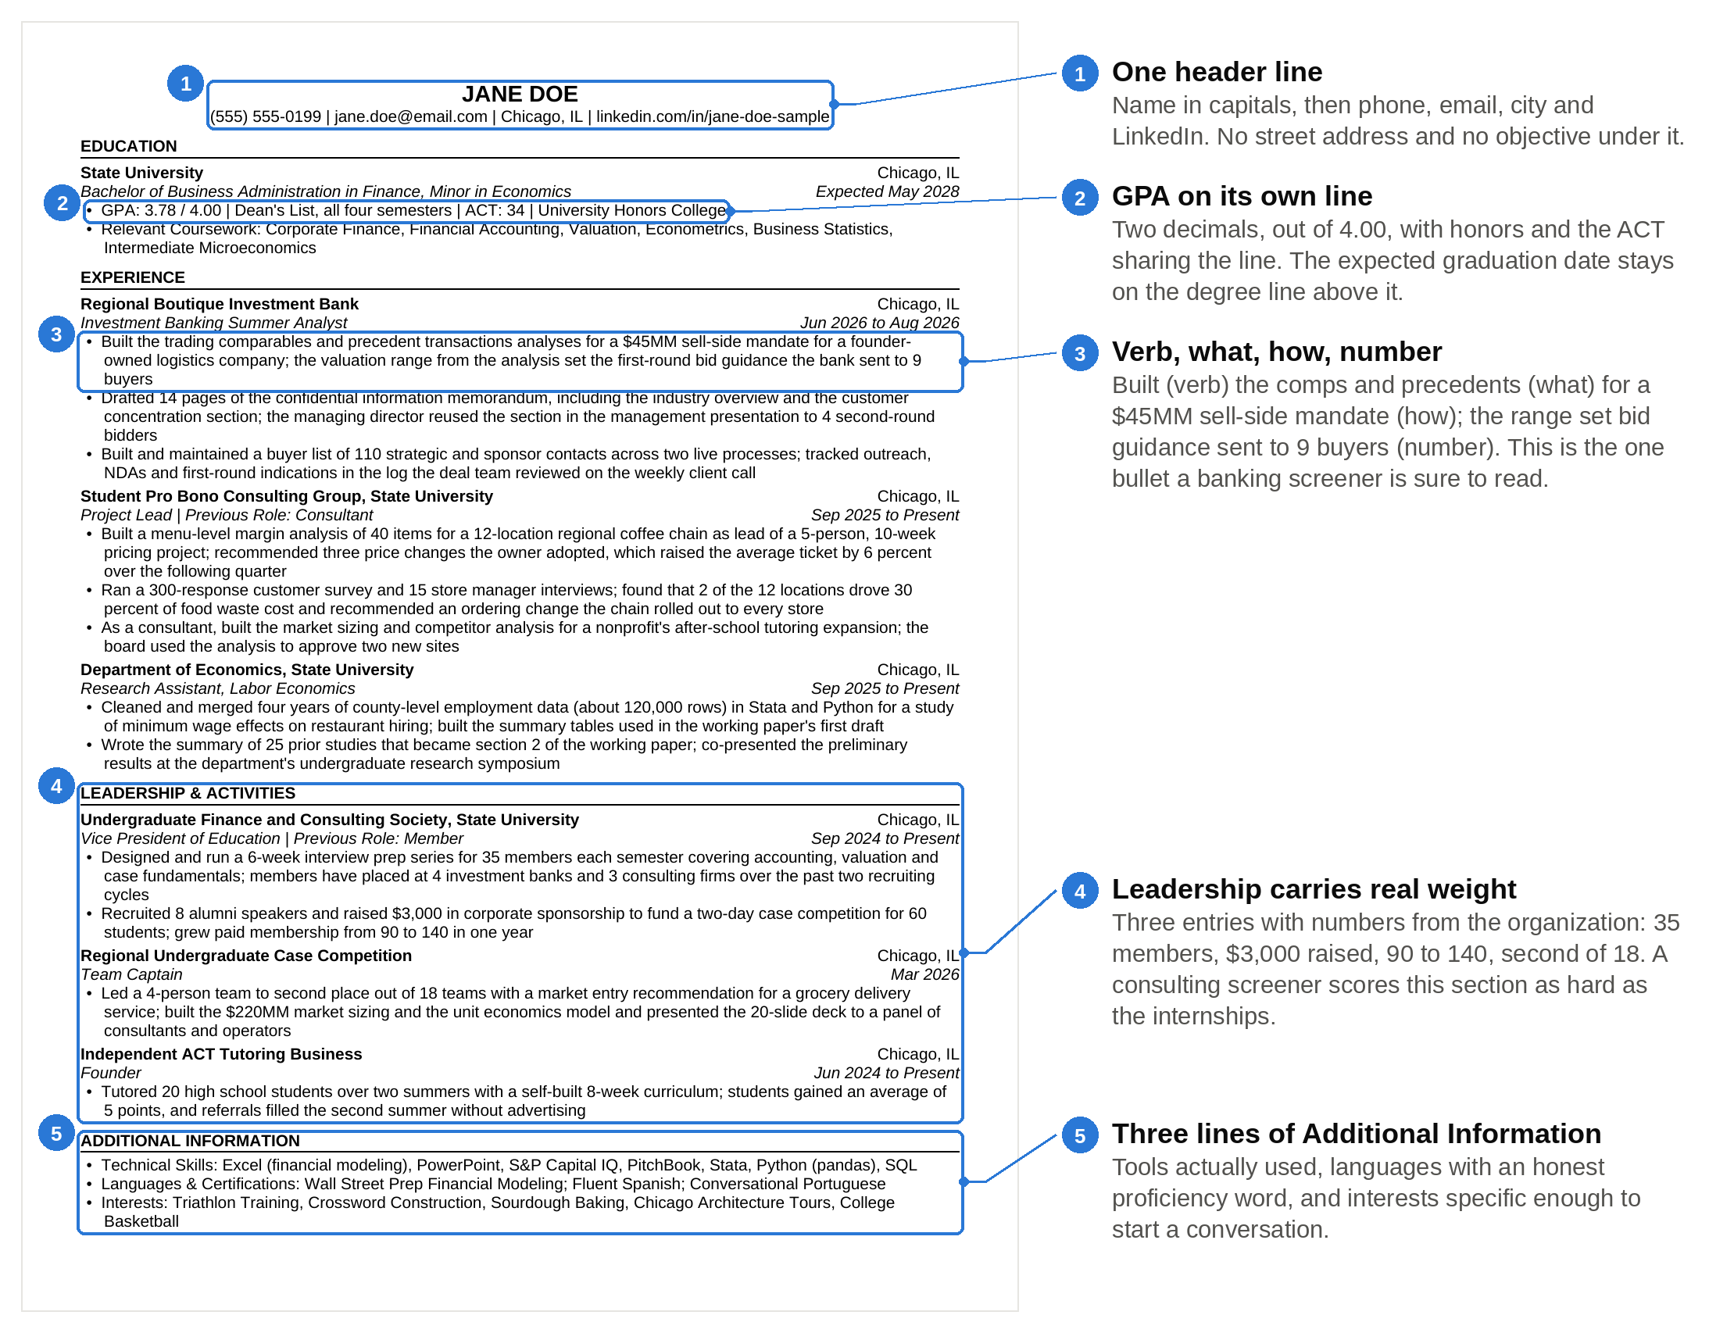
The whole page at a glance: five places a screener's eyes land, and the rule each one follows.

A few things to notice. Every bullet names the thing she made (a comps analysis, a CIM section, a margin analysis, a survey, a data set, a curriculum) so an interviewer can pick any one and say "walk me through this" and she has five minutes of material. Every bullet ends in what happened next: a bid range sent to 9 buyers, a price change the owner adopted, a section in a working paper, a second summer filled by referrals. The banking words in her first role are real deal work. Trading comparables, or comps, is a table of similar public companies and what the market pays for each dollar of their earnings, used to put a value range on the company being sold. Precedent transactions is the same idea using prices paid in past deals. A confidential information memorandum, or CIM, is the long document a bank writes to sell a company to buyers. A sell-side mandate means the bank was hired by the seller. Two consulting words show up too. Market sizing is an estimate of how much a whole market spends in a year, and unit economics is the profit or loss on one order or one customer. If any of those appear on your page, you should be able to explain them this plainly in an interview. A screener trusts a bullet they could cross-examine, and every bullet on this page would survive five minutes of questions.

4. Section rules: what goes in each block and what gets cut
The rules below are the same ones in the live banking article, stated once here so the two articles never contradict each other, with the consulting angle added where the two screens differ.

The header line

One line. Capitals for the name, 12 to 14 point at most, then the four contact items separated by a vertical bar. Use a university or plain personal email, never a nickname address. Shorten your LinkedIn URL in your LinkedIn settings so it reads linkedin.com/in/first-last. Leave off your street address, a second phone number, your pronouns, and any line about citizenship or work authorization unless a specific portal asks for it, in which case the portal has its own field.

Education

Degree line: university, city and state, the degree spelled out, your major, your minor if you have one, and "Expected" plus the month and year you graduate. The expected date is the first thing a recruiter checks against the program's eligibility window, so it goes on the degree line, not buried in the GPA line.

GPA goes on its own line, two decimals, out of 4.00. The rules by band:

- 3.5 and above: list it. Add your major GPA only if it is higher by at least a tenth.
- 3.3 to 3.5: list it. Add the major GPA if it is higher, and make sure the rest of the page carries numbers that show you can do the work.
- Below 3.3: leaving it off doesn't hide it. A screener who sees no GPA assumes it is below 3.3 and often lower. List it, and if the trend is up, add "Junior year GPA: 3.7" after it so the trajectory is visible.

Consulting screens weight GPA more heavily than banking screens do, so the same 3.4 that gets a second look at a middle-market bank needs a stronger leadership section to survive an MBB resume review. At the bulge brackets and elite boutiques the informal bar is also high, but a banking screener will keep reading past a 3.4 if the first role under Experience is real deal work.

Test scores. Consulting screeners read an SAT or ACT as another piece of evidence about analytical speed, especially for a sophomore with only three semesters of grades. Include it in the consulting version if it is roughly 1500 or 33 and above, and consider it at 1450 or 32 as a sophomore. In the banking version, include it only when it is at that upper level and the line has room. Below those levels, leave it off both versions. Nothing else from high school belongs on the page after freshman year.

Honors and scholarships share the GPA line, separated by vertical bars. "Dean's List, all four semesters" tells the reader more than "Dean's List" alone. Coursework is one line of four to six course names, most relevant first, and the order is one of the small changes in section 7.

Experience

Entry line in a fixed pattern: employer, city and state, then a period, then title, group or team if it matters, and the dates with "to" between them. Reverse chronological order, with one honest exception. A role that is still running can sit above a finished one even if the finished one started later, because "to Present" is the most recent date on the page. That exception is what lets the same page lead with a banking summer for banks and an ongoing consulting project for consulting firms, which section 7 covers.

Each bullet follows one formula: verb, what, how, number. Watch it get built from a bullet that fails.

Start with the bullet most sophomores write: "Assisted the deal team with financial analysis and presentation materials."

Step one, the verb. "Assisted" tells the reader someone else did the work. Replace it with the verb for the thing you actually did. Jane built something, so the bullet starts with "Built."

Step two, the what. Name the artifact. Not "financial analysis" but "the trading comparables and precedent transactions analyses." Now an interviewer knows exactly what to ask about, and a screener knows you have touched a real valuation.

Step three, the how, or the context. What was it for and how big was it? "For a $45MM sell-side mandate for a founder-owned logistics company." The size tells a banker the scale you have seen. The industry gives you a story to tell.

Step four, the number or the outcome. What happened because the thing existed? "The valuation range from the analysis set the first-round bid guidance the bank sent to 9 buyers." The analysis mattered to the deal, and the 9 is a real detail nobody invents.

Put together: "Built the trading comparables and precedent transactions analyses for a $45MM sell-side mandate for a founder-owned logistics company; the valuation range from the analysis set the first-round bid guidance the bank sent to 9 buyers." Two lines, one semicolon, four pieces of information a screener can use.

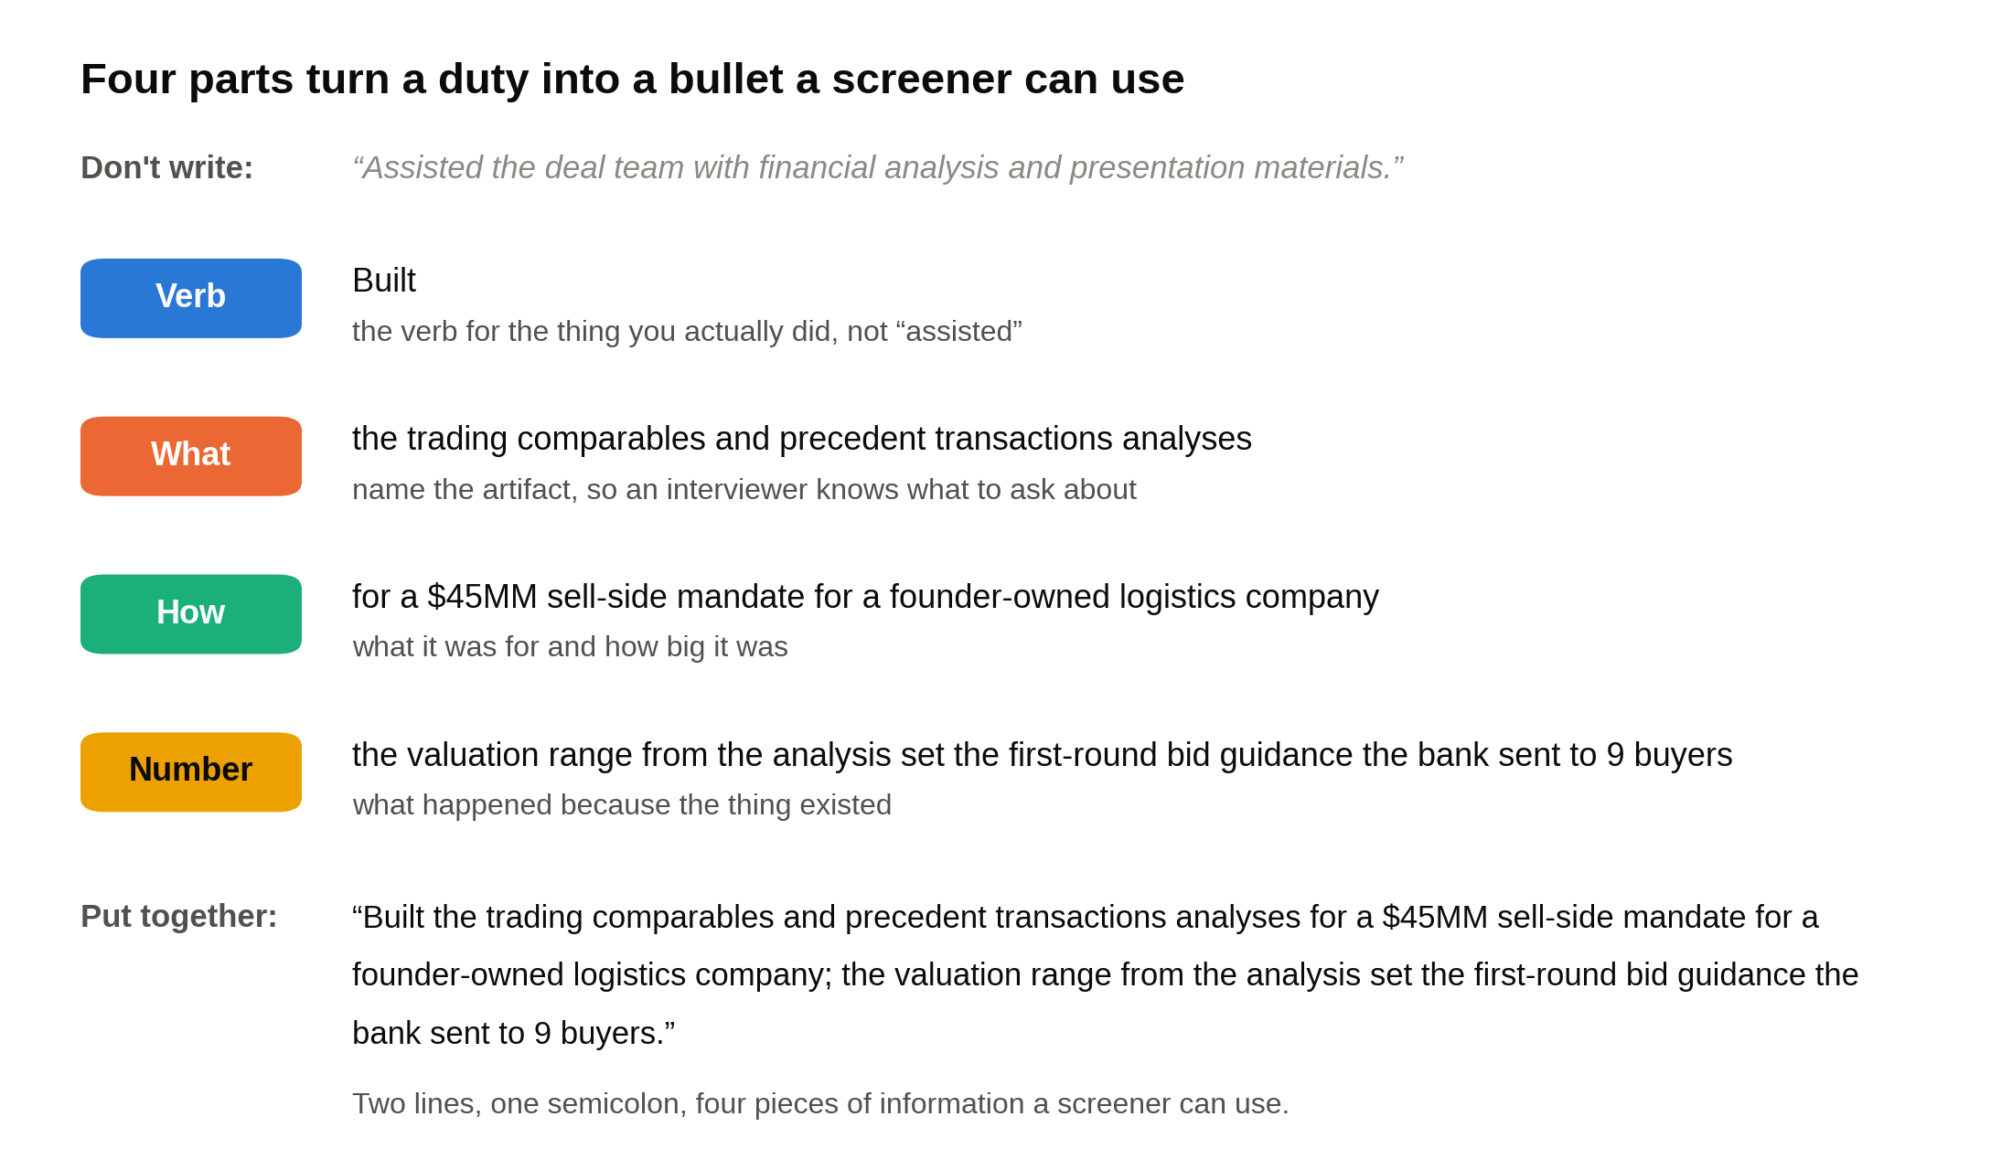
Every strong bullet on the page is these four parts in this order, and the weak version at the top has none of them.

Two bullets per role, three for your most relevant one, one to two lines each. Past tense for finished roles and present tense for current ones, and never both in the same entry. Numbers rounded the way you would say them out loud: $45MM, 110 contacts, 9 buyers. Never invent a number, because the follow-up question in the interview is always "how did you get that figure?" The eight things a banker checks in an internship application are in the IB internship CV post, and every one of them is a bullet-level check, not a layout check.

A bullet that names the artifact, the size and the outcome does the work of a cover letter in two lines, and a bullet that says "assisted with" or "responsible for" does nothing at all.

Leadership & Activities

Same entry pattern as Experience: organization, university, city, title, previous roles, dates. The bullets follow the same formula, with the numbers coming from the organization instead of a deal: members, budget, dollars raised, events run, growth from one number to another, placements, results.

Lead with what changed because you were there. "Grew paid membership from 90 to 140 in one year" beats "Responsible for membership growth." A competition entry leads with the result, then the work: "second place out of 18 teams," then what you built to get there. A business or a job you created for yourself (tutoring, a small e-commerce store, a lawn care route) belongs here, with revenue or customer numbers, because both screens read it as initiative.

For a sophomore with one or no internships, the Leadership section is where the page gets its weight, and the numbers in it count the same as deal sizes count in Experience. Membership alone never earns a bullet. If the only thing you can say is that you attended meetings, cut the entry and give the line to something you ran.

Additional Information

Three lines. Technical Skills lists tools you have actually used in a role or a course: Excel at the modeling level, PowerPoint, a data terminal or database you have logged into, a programming language you have written a script in. Languages & Certifications lists a language with an honest proficiency word (fluent, conversational, basic) and any modeling or market certification you have finished. Interests is three to six items specific enough that a stranger could ask a follow-up question. "Reading" gets nothing. "Sourdough baking" gets a conversation at the superday.

What never goes on the page: an objective or summary paragraph, a photo, a skills section with "Microsoft Word, communication, teamwork," references or "references available upon request," a second page, color, icons, or a two-column layout. Every one of those costs space and gives the screener nothing they can score.

5. How a banking screener reads the finance resume template
A 2012 eye-tracking study by TheLadders, a job search site, put 30 recruiters in front of resumes for 10 weeks and recorded where their eyes went. They spent about six seconds on the first pass, and roughly 80 percent of that time landed on six items: the name, the current title and company, the previous title and company, the dates on both, and education. The study covered experienced hires and the six-second figure has been argued over since, but the shape matches what students tell me about bank screens. The first pass is a scan of anchor points. Only the resumes that pass the scan get read.

On a student page, the anchor points are the school, the GPA, the employer names and titles down the left margin, and the dates. That is why the format is fixed. A banker who has read a thousand resumes in this layout finds those six items without looking for them, and the six seconds go to judging them instead of hunting for them.

The second pass is the 20 to 30 seconds. Here the banker reads the first bullet under your most recent role and asks two questions. Has this person touched real work, and did it matter? Deal words answer the first question: model, comps, CIM, data room (the online folder where buyers read a seller's documents), buyer list, diligence. Numbers answer the second: a deal size, a count, a percentage, a result. The second and third bullets get read only if the first one earned it. The first bullet under your most recent role is the only bullet a banking screener is guaranteed to read, so it carries your strongest deal work and your best number.

Three other things a banking screener is checking without thinking about it. Formatting consistency, because the analyst job is partly formatting pitch books at midnight and a date written "June 2026" in one entry and "Jun 2026" in the next is a preview of how you'll format a page. Interest signals, because a bank wants to know you'll still want the job in February: an investment club, a modeling certification, a finance course sequence. And the GPA against the bank's informal bar, which varies by bank and group but which almost nobody at a bulge bracket or elite boutique will say out loud.

A banking screener gives your page one scan and one read, and the format exists to make both of them land on the evidence instead of the layout.

6. How a consulting screener reads the same page
Consulting screens read more of the page, and they read it against a rubric. McKinsey takes in about a million applications a year and hires around 1 percent of them [VERIFY: McKinsey application volume and hire rate, Fortune January 2026 citing the firm's 2024 statement to Business Insider]. At that volume the screen has to be systematic, and at MBB it often involves a recruiter's first pass plus consultants from your school's recruiting team reading the resumes that survive. What they score, in roughly this order: academics, leadership, impact, and something distinctive.

Academics means the GPA and, for underclassmen, the test score, read as evidence you can learn fast. That is why the consulting version of the page keeps a strong SAT or ACT that the banking version might drop.

Leadership means you ran something and other people followed. A consulting screener reads the Leadership section as closely as the Experience section, which is the single biggest difference from a banking read. Vice President of Education for a 140-member society, Project Lead for a 5-person team, Team Captain, Founder: those titles get read, and the bullets under them get read for whether anything changed because you held the title.

Impact means a number that moved. In Jane's page, the 6 percent increase in average ticket, the 90 to 140 membership growth, the two new tutoring sites a board approved. Impact in a leadership role counts the same to a consulting screener as a deal size counts to a banker. The job is making a client's number move, and the resume is the first proof you have done it anywhere.

Distinctive means a line the screener will remember after fifty resumes. Fluent Spanish. A tutoring business that filled itself through referrals. A triathlon. Interests and the Additional Information section do more work in a consulting read than in a banking one, so leave the three lines in and make them specific.

A consulting screener reads the whole page against four things, academics, leadership, impact and distinctiveness, and your Leadership section is scored as hard as your internships. The live consulting resume checklist grades a page line by line against that read, and the firms worth grading for are in the 15 best consulting internships list.

7. The six changes that tilt the same finance resume template toward banking or consulting
In 1482, Leonardo da Vinci wrote to Ludovico Sforza, who ran Milan, asking for work. The letter is a numbered list. Portable bridges first, then ways to drain a moat during a siege, then cannons, tunnels, armored vehicles and warships. Painting and sculpture come at the very end, in a line or two, because Milan was at war and Sforza was buying military engineering. The letter is often called the first resume, and it worked: Leonardo spent almost two decades in Milan. He listed the skills he'd always had, in the order that reader cared about.

That is the whole idea behind tilting one page two ways. Nothing on Jane's page changes between the banking and consulting versions except order and emphasis. The sample in section 3 is her banking version. Here are the six changes that turn it into the consulting one.

One. Which role sits first under Experience. The banking version leads with the Investment Banking Summer Analyst role, because deal work is what a banker scans for. The consulting version leads with the Student Pro Bono Consulting Group, which runs "to Present" and so is the most recent entry by date, and which puts a client recommendation the owner adopted in the first bullet a consultant reads. Both orders are chronologically honest.

Two. Which bullet sits first under the banking role. Banking version: the comps and precedent transactions bullet, because the valuation range set a bid guidance. Consulting version: the CIM bullet, because drafting 14 pages of an industry overview that a managing director reused in a client presentation is the closest thing on the page to consulting work, written synthesis a senior person put in front of a client.

Three. Where the extra line goes. One page has a fixed number of lines, so a tilt is often a trade. The banking version gives the banking role its third bullet, the buyer list, and holds the case competition to one bullet. The consulting version gives the case competition a second bullet about the structure she used and the Q&A with the panel, and moves the tutoring business up a slot, paying for it by cutting the buyer-list bullet to one line.

Four. The Education line. Both versions keep "ACT: 34," because 34 clears the bar for either reader. If Jane were a sophomore with a 32, the consulting version would keep it and the banking version would drop it; as a junior with four semesters of grades, a 32 would come off both. The coursework line reorders: Corporate Finance, Financial Accounting and Valuation first for banks; Econometrics, Business Statistics and Intermediate Microeconomics first for consulting firms. Same six courses.

Five. Additional Information. The banking version leads Technical Skills with Excel modeling, S&P Capital IQ and PitchBook, and puts Wall Street Prep first on the certifications line. The consulting version leads with Stata, Python and SQL, and moves Fluent Spanish to the front of its line. Interests stay identical in both.

Six. Which half of each bullet comes first. Jane's bullets each carry an artifact and an outcome. A banker wants the artifact first and the outcome second; a consultant wants the decision and the people first. One bullet, written both ways:

- Banking version, as on the sample: "Built a menu-level margin analysis of 40 items for a 12-location regional coffee chain as lead of a 5-person, 10-week pricing project; recommended three price changes the owner adopted, which raised the average ticket by 6 percent over the following quarter"
- Consulting version: "Led a 5-person team on a 10-week pricing project for a 12-location regional coffee chain; built a menu-level margin analysis of 40 items and recommended three price changes the owner adopted, which raised the average ticket by 6 percent over the following quarter"

Same facts, same length. The banking version opens on the model. The consulting version opens on the team and the client.

Here are the six changes marked on Jane's page, the banking read on the left and the consulting read on the right.

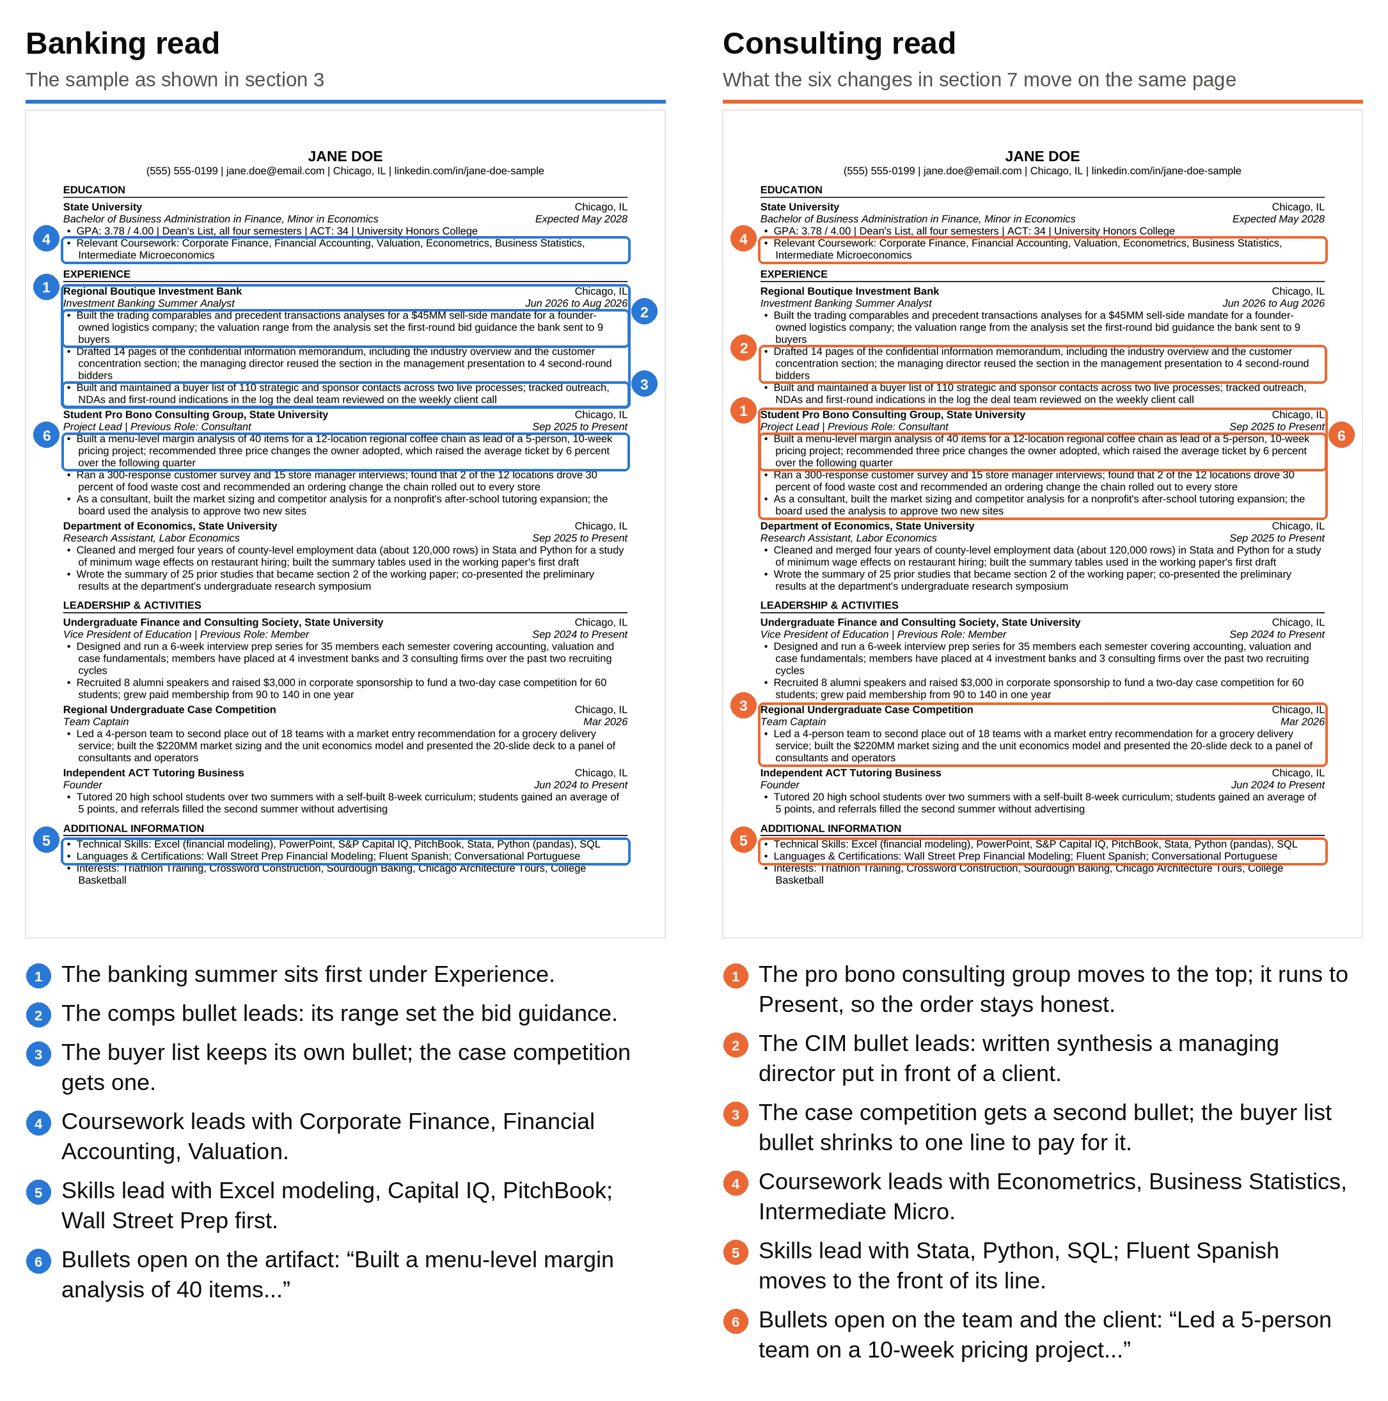
Same page, same facts: the six boxes are the only things that move between the banking version and the consulting version.

What never changes between the two versions: the page count, the five sections, the GPA, every number, the formatting, the interests, and the contact line. A bullet that is true in one version and not in the other isn't a tilt. It's a lie, and the interview will find it.

8. File naming, PDF, and the upload itself
Name the file with your name and nothing else: Jane-Doe-Resume.pdf. Not "Resume.pdf," which a recruiter cannot find in a folder of three hundred, and not "Jane-Doe-Resume-Consulting-v3-FINAL.pdf," which tells the bank you sent them a version. If you keep two versions, keep them in two folders on your computer named Banking and Consulting, and give both files the same clean name.

Export to PDF from Word or Google Docs, and never scan or screenshot a printed copy, so the text stays selectable and the tracking system can read it. Open the PDF on your phone once. If anything wraps to a second page or a bullet breaks mid-word, fix it in the source and export again.

Fonts: Times New Roman, Garamond, Calibri or Arial, 10 to 11 point for body text, one font for the whole page. Margins between 0.5 and 0.75 inches. If you can't fit the page at 10 point and 0.5 inch margins, the fix is cutting a bullet, not shrinking to 9 point. A resume that reaches one page by shrinking the font tells the screener you couldn't decide what to cut, and deciding what to cut is the skill they were checking for.

After you upload, most portals show you the parsed fields: your name, school, each employer and title, each date range. Read them. If the system put your club in the employer field or lost a date, fix it by hand in the portal before you submit. The parsed fields are what the recruiter's search runs on, so an error there is an error on your resume even if the PDF is perfect. Bank portals for the next cycle are collected in the 10 investment banking internships to apply to in 2027 list, and the consulting portals that also ask for a letter are covered in the consulting cover letter template.

One last check before every single submission: open the PDF you are about to upload and read the first bullet. Students running two versions send the consulting version to a bank more often than you would think, and a bullet that leads with "Led a 5-person team" is fine, but a file name with "Consulting" in it or an interests line that was tailored for a specific firm is not. Read the first line of the actual file you attached, every time, because the most common dual-track mistake is uploading the right resume to the wrong firm.

9. The mistakes that get a strong finance resume cut
These are the ones I see on pages that should have gotten interviews.

- Two pages, or one page at 9 point. The content might be excellent. The screener never finds out.
- Inconsistent formatting. "Jun 2026" in one entry and "June 2026" in the next. A period at the end of some bullets and not others. Bold on one employer name and not another. Each one is small. Together they tell the reader you don't check your work, in a job that is mostly checking work.
- One typo. Especially in a firm name, a title, or a number. A screener who finds one assumes there are more.
- An objective or summary at the top. It uses the most valuable three lines on the page to say what every applicant says, and it pushes your GPA down the page, out of the first scan.
- Bullets with no numbers. "Assisted with financial analysis and client presentations" could be any internship anywhere. Without a size, a count or a result, the screener has nothing to weigh.
- Describing the organization instead of your work. A bullet that explains what the student consulting group does, or what the professor's study is about, tells the reader nothing about you. Every bullet starts with a verb you performed.
- A skills section full of software everyone has. Microsoft Word, Google Docs, "strong communication skills." Cut the section and keep the three lines of Additional Information.
- Leaving the GPA off. A missing GPA reads as a low GPA. List it and show the trend.
- Headers in text boxes, a photo, icons, two columns. Each one risks a bad parse in the tracking system and gains nothing with a human reader.
- Inflating a bullet past what you can defend. "Led" when you attended, "built" when you updated. The interviewer asks "walk me through this," and the answer ends the interview.
- The wrong version to the wrong firm. Covered in section 8, and still the most avoidable mistake on this list.

10. Say this, don't say that: bullet rewrites for the dual-track page
The same bullet, written as most students write it and then the way a screener wants to read it. Each "Write" line follows verb, what, how, number.

The internship bullet with no number
Don't write: "Assisted the deal team with financial analysis and presentation materials for client meetings."
Write: "Built the trading comparables analysis for a $60MM sell-side pitch to a packaging company; the valuation page anchored the range the managing director presented to the founder."

The responsibility bullet
Don't write: "Responsible for maintaining the buyer list and tracking outreach for live deals."
Write: "Maintained a buyer list of 110 strategic and sponsor contacts across two live sell-side processes; logged every NDA and first-round indication for the deal team's weekly client call."

The club bullet that lists duties
Don't write: "Organized events, managed the club budget, and helped recruit new members for the finance society."
Write: "Raised $3,000 in corporate sponsorship to fund a two-day case competition for 60 students; grew paid membership from 90 to 140 in one year."

The research bullet about the professor's project
Don't write: "Worked on a study examining the effects of minimum wage changes on restaurant employment."
Write: "Cleaned and merged four years of county-level employment data (about 120,000 rows) in Stata and Python; built the summary tables used in the working paper's first draft."

The case competition bullet with no result
Don't write: "Participated in a case competition and presented a market entry strategy to a panel of judges."
Write: "Led a 4-person team to second place out of 18 with a market entry recommendation for a grocery delivery service; built the $220MM market sizing and the unit economics model."

The pro bono consulting bullet without the client's decision
Don't write: "Consulted for a local coffee chain on pricing strategy as part of a student consulting group."
Write: "Led a 5-person team on a 10-week pricing project for a 12-location coffee chain; recommended three price changes the owner adopted, raising the average ticket by 6 percent the next quarter."

The skills line
Don't write: "Skills: Microsoft Office, teamwork, leadership, communication, problem solving, attention to detail."
Write: "Technical Skills: Excel (financial modeling), PowerPoint, S&P Capital IQ, Stata, Python (pandas), SQL."

The interests line
Don't write: "Interests: Reading, traveling, sports, music, spending time with friends."
Write: "Interests: Triathlon Training, Crossword Construction, Sourdough Baking, Chicago Architecture Tours, College Basketball."

The summary paragraph
Don't write: "Motivated finance student seeking an internship in investment banking or consulting where I can apply my analytical skills."
Write: nothing. Delete the paragraph and let the Education line be the first thing the screener reads.

Where this leaves you
Build the page tonight from the blank template, with your real numbers, and stop at one page before you have decided what to cut. Then rank every bullet by how well it would survive "walk me through this," and cut from the bottom until it fits. Save the banking version. Make the six changes from section 7, save the consulting version, and give both files the same clean name in two different folders.

Then hand the banking version to someone who has never seen it and take it back after ten seconds. Ask them your school, your GPA, your most recent employer, and one number from the page. If a stranger can name your school, your GPA, your last employer and one number after ten seconds with the page, the format has done its job. If they can't, the content was never the problem.

